Link/2500 Accessories

Protective Cover
Art. 23406
€19.95 excl. VAT
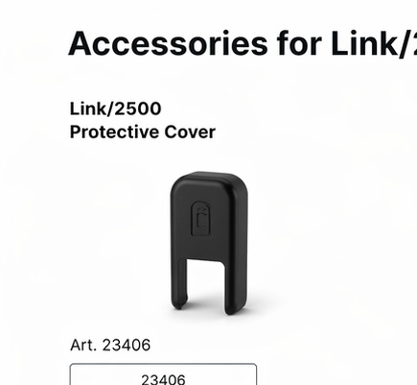

Protective Cover + Lanyard
Art. 23407
€24.95 excl. VAT
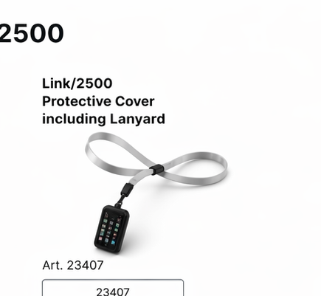

Desktop Stand + Cover
Art. 23408
€59.95 excl. VAT
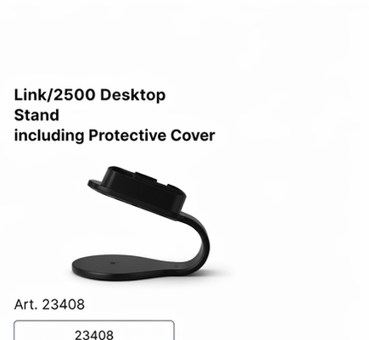

Multi-Charger (3 terminals)
Art. 23072
€159.95 excl. VAT
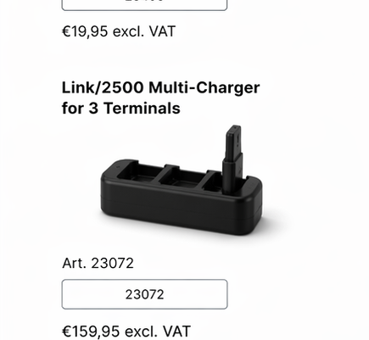

USB Cable (USB-A to USB-C 1.5m)
Art. 23400
€5.95 excl. VAT
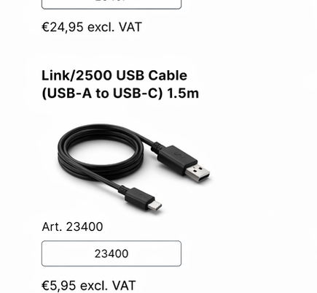

Power Supply (5V-1A USB-A)
Art. 23402
€7.95 excl. VAT
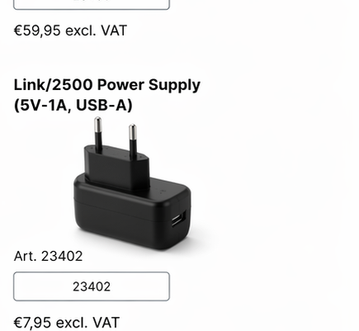

Battery (1200mAh)
Art. 23401
€27.95 excl. VAT
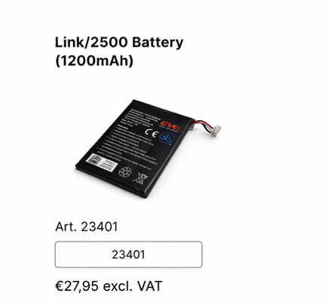

Payment Stickers
Art. N/A
€0.00
